Pandemic Modeling using Cell-DEVS and CD++

Glenn Davidson

101205195

Nov-13-2020

SIR modeling is a long-established pandemic modeling framework first described by differential equations. The model divides members of a static population into one of three categories: Susceptible (S), Infected (I), or Recovered (R). A pandemic evolves over time as Susceptible members of a population become Infected, and eventually become Recovered.

Susceptible individuals become Infected through a constant number of interactions each person in the population is assumed to have each day. A constant proportion of the Infected population becomes Recovered each day according to a recovery rate. Several unrealistic assumptions are made in basic SIR models – there is no death or immigration, members of a population are equally likely to interact no matter their state, all members of the population behave identically, and consideration of geographical space. A Cellular Automata model based on differential equations can begin to extend these concepts into physical space.

An already existing SIRS model defined in [3] was used to generate new scenarios and explore different infectivity profiles. This model considers the recovered state as temporary, granting an effective immunity for a set number of days before they become Susceptible again. This model will be expanded upon to increase the accuracy of the incubation period in COVID-19, and will include a new state “Not Contagious” which will represent the portion of population that will become sick after a time, like an Exposed person in a SEIRS model, where all sufficient exposures will result in infection.

A pathogen’s incubation period is defined as the number of days before an infected person shows symptoms, and is an important variable in predicting disease. A meta-analysis of the incubation period of COVID-19 was used to generate a symptom onset profile for COVID-19 (the probability of becoming Infected on each day). The incubation period in COVID-19 has been shown to follow a log-normal distribution [1], with a mean onset time of 5.6 days and showing as late as 24 days.

It is important to consider that an infected person will shed active virus before showing symptoms, which is harder to predict for COVID-19 because of the lack of data. The incubation period can be inferred from the difference in symptom onset between transmission pairs, and a profile of virus shedding can be obtained from a symptomatic person, but collecting a virus shedding profile from a person who does not know they will become sick is a logistical challenge. The amount of virus shed before symptoms start can be inferred from what is known about the virus shedding profile of symptomatic COVID-19 infections, and profiles of other coronaviruses. An infected person can shed a significant amount of virus starting two days before the arrival of symptoms [2]. Therefore, the only way to prevent pre-symptomatic virus transfer in a non-vaccinated population is through contact tracing. This model will be adapted to include a variable incubation period during which virus is shed two days before symptoms arrive. A log-normal distribution matching [1] will determine on what day each proportion of the exposed population will get sick, upon which time they enter a proper infection cycle.

**SIRS Model Specification:**

The model described in [3] can be specified as in terms of the parameters X, Y, S, θ, I, N, d, τ, D, which the reader is assumed to be familiar with. The DEVS portion of the Cell-DEVS specification is omitted for clarity as DEVS is not explicitly used in the model. Note that the cured rate in the paper is described in terms of a function, but is a static value in this model.

**S (cell state variables):**

* Population = The total population size of the cell. {0..x} where x is a non-negative integer
* Connection factor = {0…1}
* Movement factor = {0...1}
* Cured Rate = {0…1}
* Infected State Max Days = {22}*
* Recovered State Length {6}*
* Susceptible Proportion = {0...1} - discretized in increments of 0.01
* Infected Proportions = {0…1} (1-22) - discretized in increments of 0.01
* Recovered Proportions = {0...1} (1-6) - discretized in increments of 0.01
* Virulence coefficients (1-22) = {0...1}

*These values are not used directly in the cell’s computation, but each cell has a number of state variables manually defined equal to these values

**X:Y (Cell Input and Output Ports)**

The input ports and output ports relay the same state information.

* Initial state flag
* Population size
* Susceptible proportion
* Infected proportions (1-22)
* Recovered proportions (1-6)

**Delay of Cell:**  1 time unit in all cases, transport delay – corresponds to 1 day.

**Neighborhood:** Size = 5, von Neumann neighborhood

**Border Conditions:** Wrapped

**τ (local computation function):**

The local computation function can be described by a set of formulas given in [3], and can be seen in appendix B. The local computation function can be by the following rules:

Rule 1: If in initial state, state variable initial = 0 and do all port assignments, delay = 1

Rule 2: If not in initial state do:

*Infected Days 2-22 = Infected of previous day * (1 – cured rate)*

*Infected Day 1 = new infected internal + new infected external*

*Recovered Day 2-6 = Recovered of previous day*

*Recovered Day 1 = Infected of day 22 + proportion cured from infected population days 1-21.*

*Susceptible = 1 – ∑Recovered – ∑Infected*

Doport assignments, delay = 1.

**SEIRS Model Specification:**

The proposed SEIRS model is identical to the SIRS described above except there added state variables and the τ has been modified.

**Additional State Variables:**

Exposed 1-24 (proportion of population in exposed state), Incubation Coefficients 1-24 (representing the probability of getting sick on each day)

**τ (local computation function):**

*Recovered Day 2-6 = Recovered of previous day*

*Recovered Day 1 = Infected of day 22 + proportion cured from infected population days 1-22.*

*Infected Days 2-22 = Infected of previous day * (1 – cured rate)*

*Infected Day 1 = proportion of exposed developing symptoms + Exposed of day 24*

*Exposed Days 2-24 = Exposed of previous day * (1 – P(developing symptoms this day))*

*Exposed Day 1 = new exposed internal + new exposed external*

*Susceptible = 1 – ∑Recovered – ∑Infected*

Note that the Exposed state does not contribute to new infections, nor does it influence Recovered or Susceptible populations. It is an intermediate state that introduces a delay in the infectivity of the virus, based on the log-normal distribution representation of the incubation period of COVID-19, and does not interact with other populations as Recovered does. Therefore, no new ports are added to the cell to introduce this state.

**Experimentation with Original Model:**

Experiments were conducted using the original SIRS model by varying the population and mobility in a few cells to see the response. Two scenarios included: a completely uniform population with one infected center cell, and a non-uniform population starting with one infected cell. In all simulations the top first (top left) square is the Susceptible population, the last 6 squares are the Recovered population in days 1-6 of Recovery, and the remaining squares (22) are the Infected population on days 1-22 of their infection, seen in Figure #1.

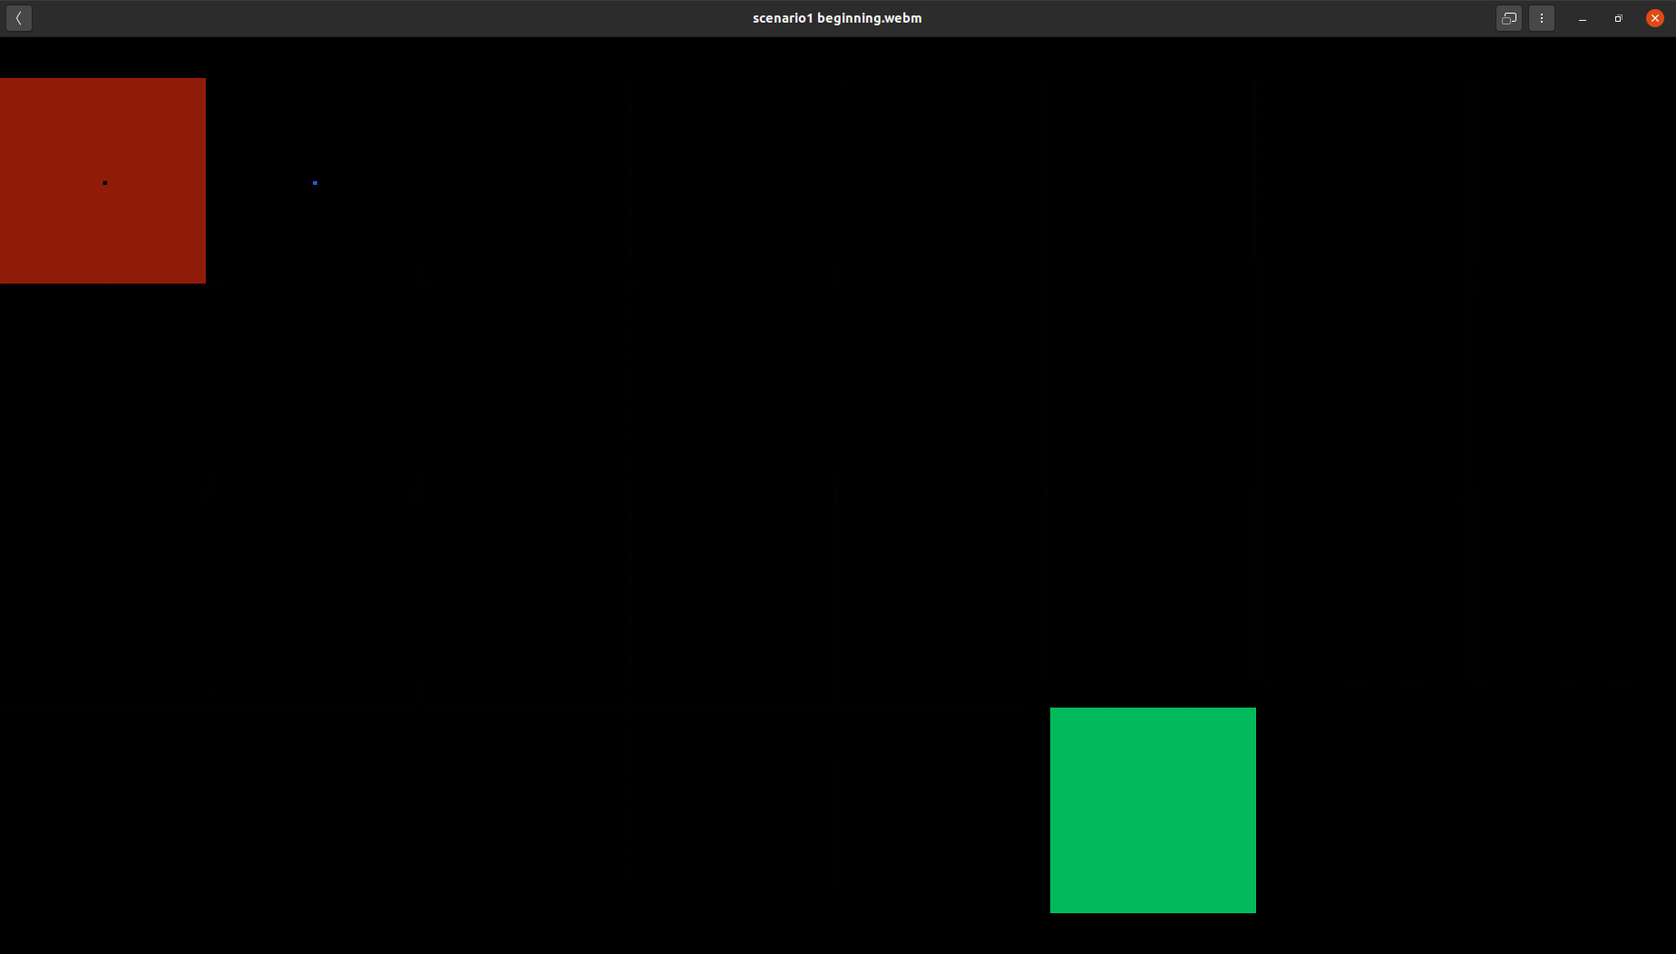

**Figure #1: Scenario 1 Initial Conditions**

By observing Scenario 1, a baseline of behaviour is established for the set of models and scenarios to come. The population begins almost all red (100% S), while the infected and recovered populations begin almost all dark blue (0%), the exception to these being the infected cell specified in the initial conditions. As the simulation progresses, the infection spreads outward in a ring, and the population in various days of infection can be seen in the 22 infection cell state displays, becoming light blue (low 5%-20%), and even slightly grey (med 40-60%). All simulations were done using a 50x50 cell space, and most simulations were done with a uniform population of 100 in each cell unless specified otherwise.

A series of different scenarios were run with the original model, a modified version of the model, and finally the SEIRS version of the model was attempted but unsuccessful. The scenarios run will be described and shown as images in key parts of the simulation. Each simulation video displays the evolution of 30 state variables. The first view displays the Susceptible population (0-100%), the last view displays the cell space populations. The remaining state views in between are the Infected population days 1-22, and Recovered population days 1-6. The remaining two views after cell space population are not used, but blend into the color scheme of the display. The color scheme can be understood as : black (0%), blues/purples (0.1-30%), light blue/grey(30%-80%) and red (80-100%) where percent denotes a state variable value easily understood as percentage of population.

**SIRS Zhong Scenario 1:**

The initial conditions of scenario 1 (Figure 1) are a uniform population, a single infected cell in the middle, and the rest of the population as Susceptible. The infected population has a constant infectivity for 8 days, and then they isolate and become only slightly contagious.The infection spread outwards uniformly in a circle until and becomes a ring as the center of the cell space becomes susceptible again. The infection is not sufficient to persist in the center, and a Susceptible ring builds in the center until the entire population becomes susceptible again and the infection has disappeared. The evolution of the pandemic from initial conditions can be seen in Figures #2. The effect of the population becoming recovered on any of the 22 days can be seen in the recovered state variables as two rings, where a few quick recoveries appear in the region of newest infections.

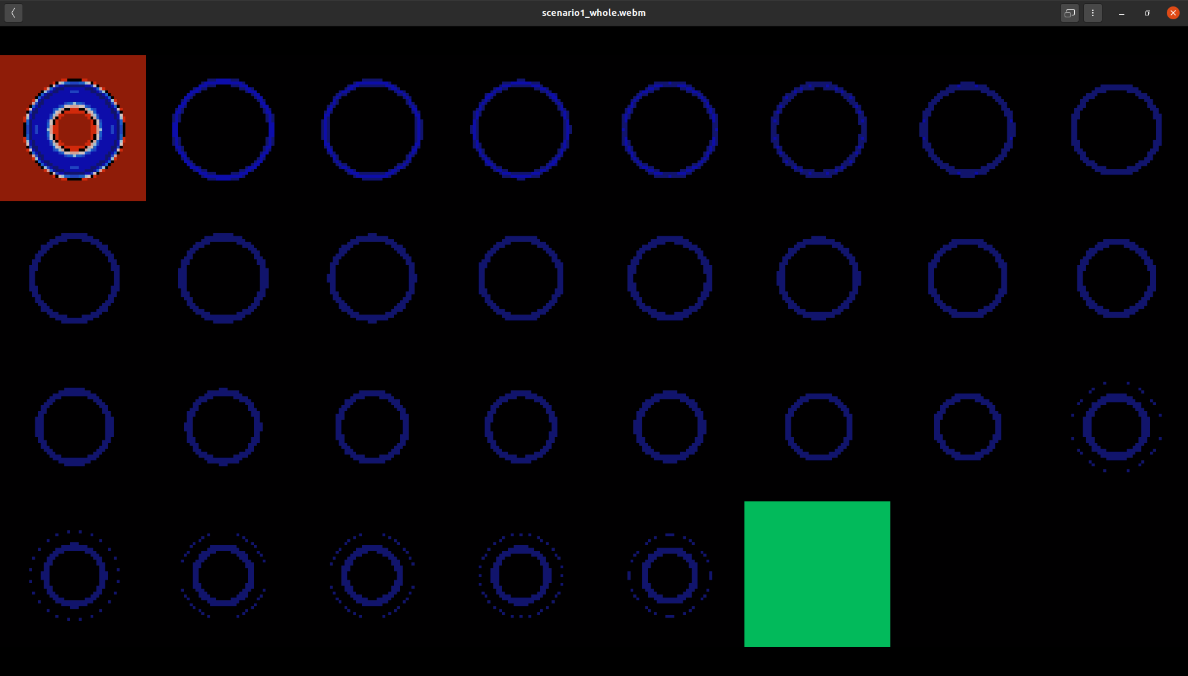

**Figure #2: Scenario 1 Mid-Pandemic**

**SIRS Zhong Scenario 3:**

The next scenario under consideration is that of a border slowing the spread of infection but not stopping it. Initially the approach of using lower mobility factors for the border cells was tried, but using two different mobility factors appear not to work. A non-uniform population was then tried to implement the border and it did succeed. The lower population can be seen in the green view and is 5 cells wide with population size 10 in each cell. The single infected cell sits directly below the center of this low population border. The initial conditions can be seen in Figure #3 below.

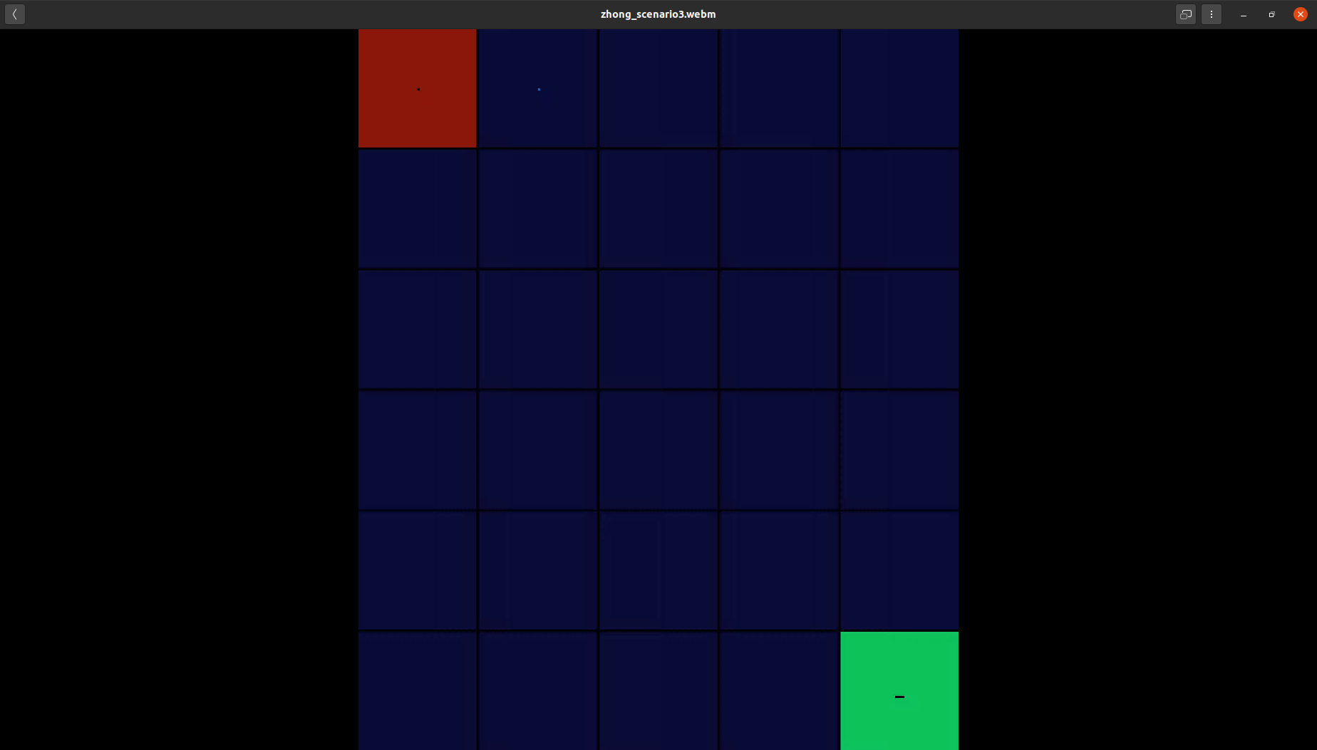

**Figure #3: Small Low Population Border Initial Conditions**

The border does introduce a non-uniformity in the spread of the infection as expected, as has a small blocking effect early in the simulation. This effect also delays the progression of the infection, seen in Figure #4, where a higher concentration of infection can be seen towards the center of the circle and delayed from the front of new infections. The simulation resembles the first scenario once the border cells and their effects enter Recovered and Susceptible.

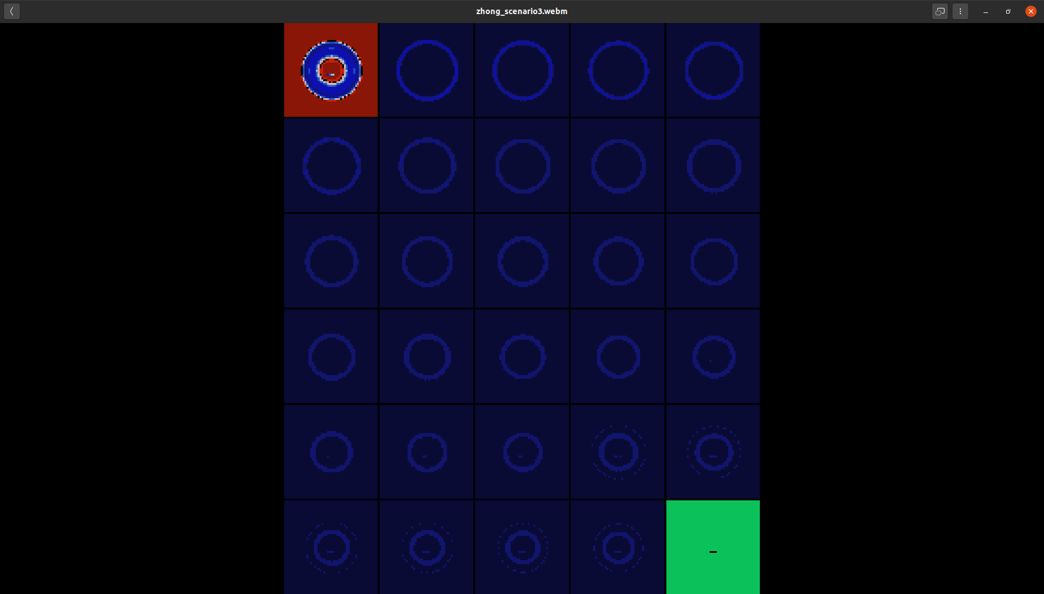

**Figure #4: Effect of Low Population Border**

**Zhong Scenario 4:**

Next a low population border was introduced around the border of the cell space, and through the center, effectively dividing it in two. The same single infected cell in the center of the cell space was used to start the infection in the lower space, seen in Figure #5. A C++ program labeled “var_generator.cpp” was written to generate the .var file used for this simulation and is included in the project.

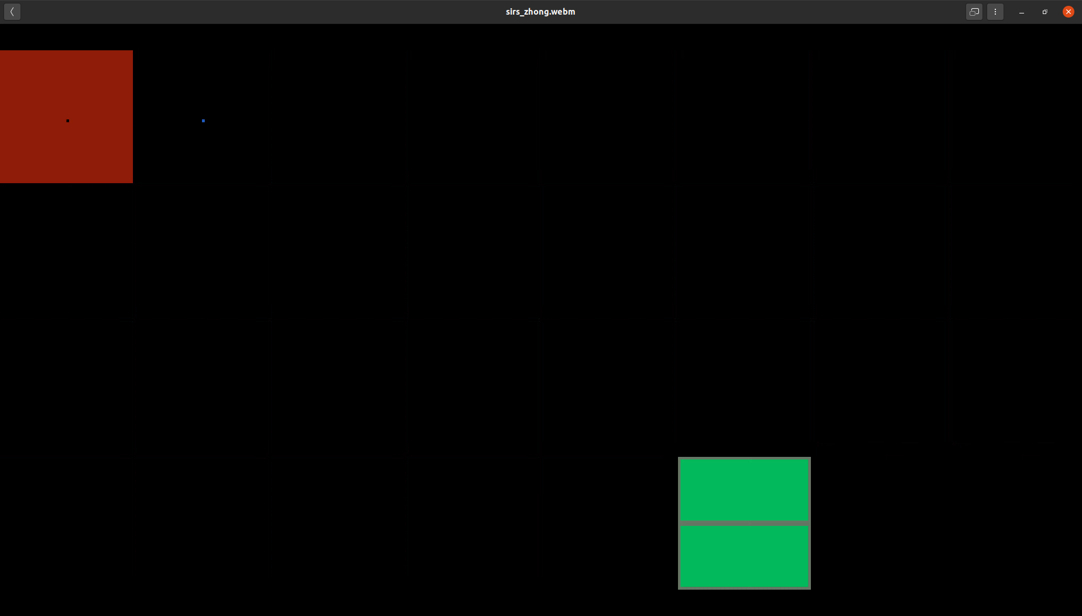

**Figure #5: Initial Conditions of Uniform Border Test**

The effect of the low population border behaves as one would expect in the early stages of the simulation. The infection spreads much faster in the lower region than in the upper, seen in Figure #6. The simulation diverges from what one would expect in the later stages (Figure #7), and appears to never converge, at least not in any reasonable time frame to be simulated.

The infected cell (25,25) begins the infection on one side of the border, and the border initially obstructs the infection. As the infection spreads along the border and throughout the cell space, the border remains a persistent infector of the population. Perhaps this effect can be viewed as a separate population, like a force of border guards that continue to infect one another near the center cell space. The simulation shows that border guards in the late days of their infection are driving the infection, even when isolated after day 8 and their virulence factor is quite low. Later in the simulation set of infected cell states show that there is a particularly high proportion of border guards that are in the early days of their infection. The effect of the wrapped border can also be seen later in the simulation effectively perpetuating an already bad infection.

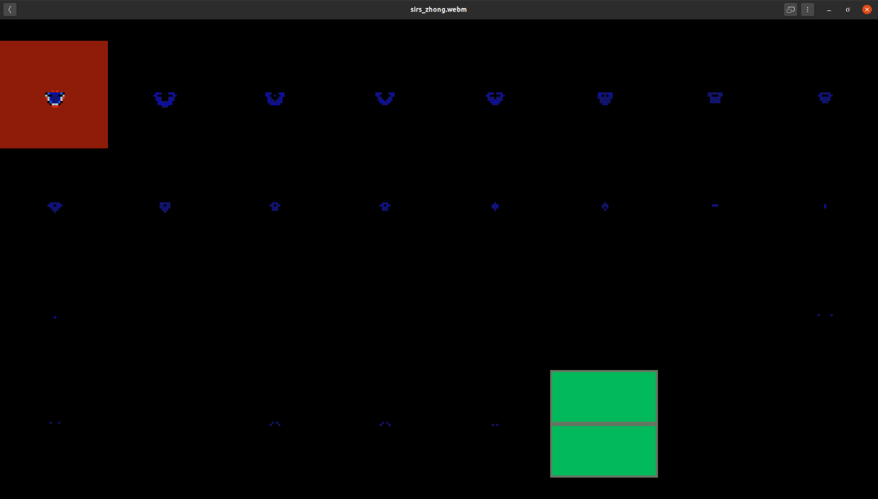

**Figure #6: Long Border Early Simulation**

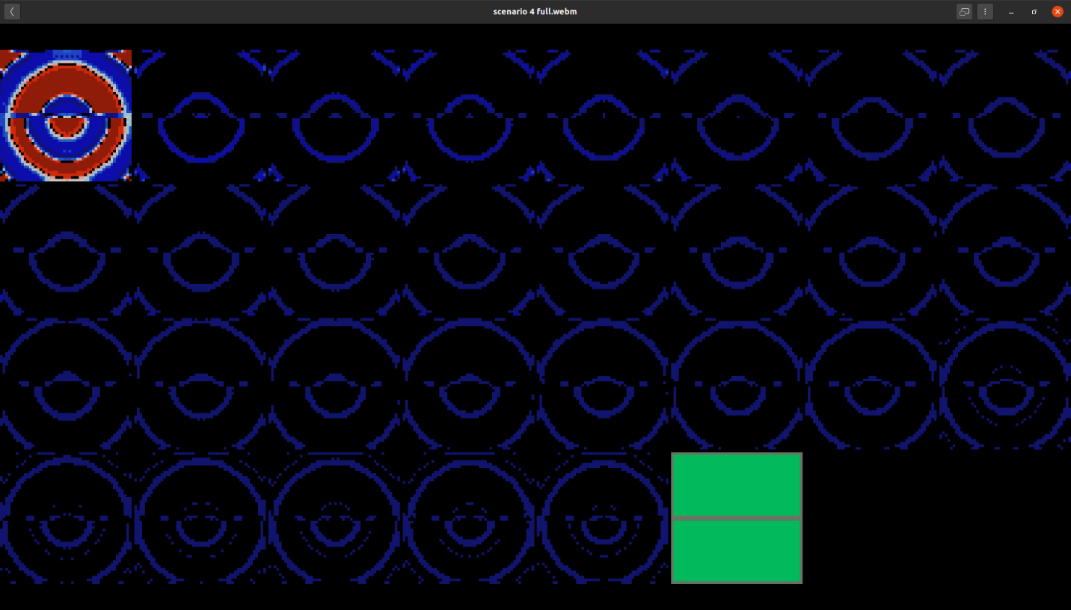

**Figure #7: Long Border Early Simulation**

**Meta Scenario 1:**

The virulence factors that describe how infections people are on each day of their infection (1-22) were modified so that they matched the mean incubation period and virus shedding profile described in [1] and [2]. The population sheds no virus on day 1, very little on day two, and then increases sharply on day 3, still before any symptoms have started in the infected. The virulence peaks on day 5, where the mean incubation time indicates that infected persons begin to experience symptoms. Simulations in the previous scenarios considered infected persons to be contagious immediately and consistently for 8 days, after which they become isolated and their virulence coefficient would decrease from 0.17 to 0.01. The new virulence profile per days 1-8 for this scenario are: 0.0 (v1), 0.02 (v2), 0.10 (v3), 0.20 (v4), 0.35 (v5), 0.35 (v6), 0.25 (v7), 0.10 (v8).

This pandemic evolves as a ring of infection expanding outwardly, taking on a sight diamond shape instead of a perfect circle. The width of the Susceptible circle is much thinner, as is the Infected and Recovered. This means that the infection is located in a smaller geographical area after the point in the simulation where the center beings to become Susceptible again. The diamond shape emerging is interesting, but it’s meaning is not easily intuited. This pandemic scenario is likely less severe because the first few days are not very infective, however if any variability was added to the incubation time as in reality, this simulation with the parameters as is would likely show a non-uniform spread of a pandemic out of control.

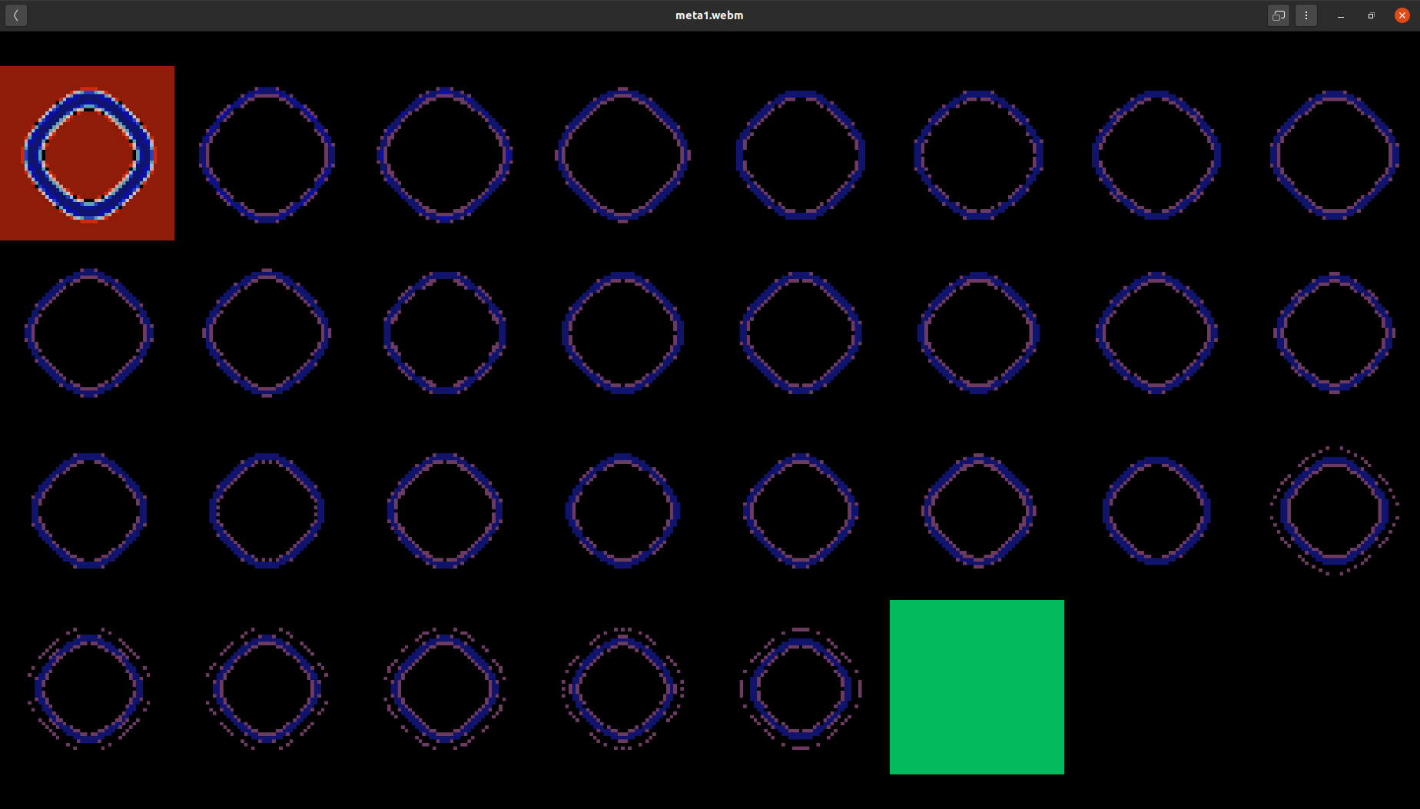

**Figure #8: Mean Time Incubation Period and Virus Shedding Profile**

**Meta Scenario 3:**

Another scenario was run using a similar virulence profile as in Meta Scenario 1 and the same initial conditions, except the population isolates after their second day of symptoms (day 6). The virulence in days 4-6 was also increased slightly. The new virulence profile per days 1-6 for this scenario are: 0.0 (v1), 0.02 (v2), 0.20 (v3), 0.40 (v4), 0.40 (v5), 0.40 (v6), and v7-v22 are 0.01 thereafter. The simulation shows a similar pandemic to Meta Scenario 1, but the ring of Infected and Recovered is thinner, meaning the infection spans an even smaller geographical region any time. This model does not have a tool to sum the total infected and total recovered on each day, so an exact metric can not be given as to whether this pandemic is more severe than Meta Scenario 1 or the SIRS Zhong Scenario 1.

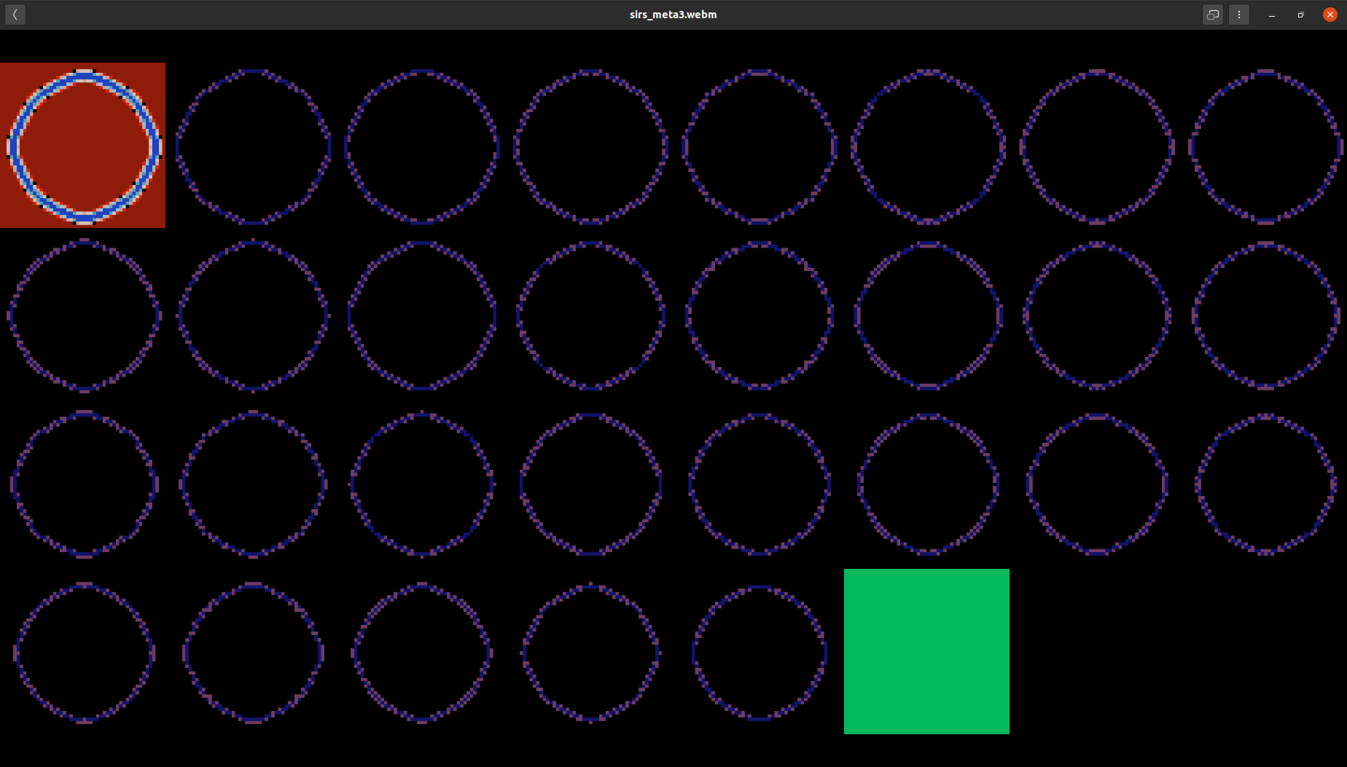

**Figure #9 : Meta Scenario 6**

**SEIRS Incubation**

The SEIRS model was attempted but does not compile. The code was still included in this project to show the intended implementation nonetheless. Appendix A shows the incubation period Log-Normal distribution that would describe the proportion of the Exposed population that would enter Day 1 infected each day.

**References:**

1. McAloon C, Collins Á, Hunt K, et al. Incubation period of COVID-19: a rapid systematic review and meta-analysis of observational research BMJ Open 2020;10:e039652. doi: 10.1136/bmjopen-2020-039652.
2. He, X., Lau, E.H.Y., Wu, P. et al. Temporal dynamics in viral shedding and transmissibility of COVID-19. Nat Med 26, 672–675 (2020). https://doi.org/10.1038/s41591-020-0869-5
3. C, Martin, Cardenas, R, Wainer, G et al. Cell-DEVS Models for the spread of COVID-19 Carleton University, University of Madrid, Retrieved from https://github.com/SimulationEverywhere/covid_cell_devs/tree/2020-ACRI

**Appendix A:**

Two incubation graphs are given for the purposes of modeling COVID-19, the first follows the meta-analysis [1] shown in table #1, and the second is for a hypothetical pandemic with a shorter incubation period shown in table #2.

|  |  |  |
| --- | --- | --- |
| **X~LogNormal(1.63, 0.5)** | | |
| **x** | P(X <= x) | P( x > X > x-1) |
| 0 | 0.0000 |  |
| 1 | 0.0007 | 0.0007 |
| 2 | 0.0349 | 0.0342 |
| 3 | 0.1580 | 0.1231 |
| 4 | 0.3345 | 0.1766 |
| 5 | 0.5075 | 0.1730 |
| 6 | 0.6493 | 0.1418 |
| 7 | 0.7555 | 0.1061 |
| 8 | 0.8312 | 0.0757 |
| 9 | 0.8838 | 0.0527 |
| 10 | 0.9200 | 0.0362 |
| 11 | 0.9447 | 0.0247 |
| 12 | 0.9616 | 0.0169 |
| 13 | 0.9732 | 0.0116 |
| 14 | 0.9812 | 0.0080 |
| 15 | 0.9867 | 0.0055 |
| 16 | 0.9905 | 0.0038 |
| 17 | 0.9932 | 0.0027 |
| 18 | 0.9951 | 0.0019 |
| 19 | 0.9964 | 0.0013 |
| 20 | 0.9974 | 0.0010 |
| 21 | 0.9981 | 0.0007 |
| 22 | 0.9986 | 0.0005 |
| 23 | 0.9989 | 0.0004 |
| 24 | 0.9992 | 0.0003 |
| 25 | 0.9994 | 0.0002 |

**Table #1: Five Day Mean Incubation Pandemic Distribution**

|  |  |  |
| --- | --- | --- |
| **X~LogNormal(1.1, 0.5)** | | |
| **x** | P(X <= x) | P( x > X > x-1) |
| 0 | 0.0000 |  |
| 1 | 0.0139 | 0.0139 |
| 2 | 0.2079 | 0.1940 |
| 3 | 0.4989 | 0.2910 |
| 4 | 0.7165 | 0.2176 |
| 5 | 0.8459 | 0.1293 |
| 6 | 0.9167 | 0.0709 |
| 7 | 0.9547 | 0.0379 |
| 8 | 0.9749 | 0.0203 |
| 9 | 0.9859 | 0.0110 |
| 10 | 0.9919 | 0.0060 |
| 11 | 0.9953 | 0.0034 |
| 12 | 0.9972 | 0.0019 |
| 13 | 0.9983 | 0.0011 |
| 14 | 0.9990 | 0.0007 |
| 15 | 0.9994 | 0.0004 |
| 16 | 0.9996 | 0.0002 |
| 17 | 0.9997 | 0.0001 |
| 18 | 0.9998 | 0.0001 |

**Table #2: Three Day Mean Incubation COVID-19 Distribution**